Web Programming
Lab Assignment 09

By: Avyakth Shriram (24BCE651)

LAB 9 – HTML Code:

<!DOCTYPE html>
<html>
<head>
<title>Objects in JavaScript</title>
</head>
<body style="background-color:blueviolet;">
<div class="container" style="padding:20vh 4vw;">
<div class="inner-cont" style="text-align:center; padding:20px; border-radius:2rem; background-color:pink; height:500px; width:90vw;">
<h1>Welcome, <span id="name" style="color:aqua"></span></h1>
<h1>Three Different Ways to Create an Object: </h1>
<div class="obj-crean" style="display:flex; gap:50px; padding:20px;">
<div class="method1">
<h1>Object Literal Method</h1>
<form>
Id : <input type="text" id="id1"/>
Name: <input type="text" id="name1"/>
</form>
<button onclick="obj1()" style="background-color:yellowgreen; margin-top:20px; border-radius:5px; order:none; width:100px; height:35px;">Click me!</button>
<p id="para1"></p>
</div>
<div class="method2">
<h1>Create Instance Of Object</h1>
<form>
Id : <input type="text" id="id2" name="id2"/>
Name: <input type="text" id="name2" name="name2"/>
</form>
<button style="background-color:yellowgreen; margin-top:20px; border-radius:5px; border:none; width:100px; height:35px;" onclick="obj2(document.getElementById('id2').value,document.getElementById('name2').value)">click me</button>
<p id="para2"></p>
</div>
<div class="method3">
<h1>Object Constructor</h1>
<form>
Id : <input type="text" id="id3"/>
Name: <input type="text" id="name3"/>
</form>
<button style="background-color:yellowgreen; margin-top:20px; border-radius:5px; border:none; width:100px; height:35px;" onclick="obj3()">click me!</button>
<p id="para3"></p>
</div>
</div>
</div>
<h1 style="color:white; text-align:center; margin-top:100px;">Use of JS objects</h1>
<div style="display:flex; gap:10%; justify-content:center; margin-top:30px; margin-bottom:30px;">
<div class="par2" style="text-align:center;">
<button style="background-color:yellowgreen; margin-top:20px; border-radius:5px; border:none; width:100px; height:35px;" onclick="calculate()">Calculate</button>
<div id="props" style="background-color:pink; border-radius: 3rem; padding:10px; width:300px; margin:auto; margin-top:20px;">
<p id="length">Length: </p><br/>
<p id="reverse">Reverse: </p><br/>
<p id="conc">Concatenation: </p><br/>
<p id="subs">Substring: </p><br/>
<p id="includes">Includes: </p><br/>
<p id="copy">Copy: </p><br/>
<p id="casecon">CaseConversion: </p><br/>
</div>
</div>
<div class="par2" style="text-align:center;">
<button style="background-color:yellowgreen; margin-top:20px; border-radius:5px; border:none; width:100px; height:35px;" onclick="calculateMath()">Calculate</button>
<div id="props" style="background-color:pink; border-radius: 3rem; padding:10px; width:300px; margin:auto; margin-top:20px;">
<p id="math-pi">Math.PI: </p><br/>
<p id="math-round">Math.Round: </p><br/>
<p id="math-floor">Math.Floor: </p><br/>
<p id="math-ceil">Math.Ceil: </p><br/>
<p id="math-sqrt">Math.Sqrt: </p><br/>
<p id="math-pow">Math.Pow: </p><br/>
</div>
</div>
<div class="par2" style="text-align:center;">
<button style="background-color:yellowgreen; margin-top:20px; border-radius:5px; border:none; width:100px; height:35px;" onclick="calculateArray()">Calculate</button>
<div id="props" style="background-color:pink;border-radius: 3rem;padding:10px;width:300px;margin:auto;margin-top:20px;">
<p id="array-length">Array Length: </p><br/>
<p id="array-reverse">Reversed Array: </p><br/>
<p id="array-sorted">Sorted Array: </p><br/>
<p id="array-sum">Sum of Array: </p><br/>
<p id="array-min">Min Value: </p><br/>
<p id="array-max">Max Value: </p><br/>
<p id ="ith element">Ith Element: </p><br/>
</div>
</div>
</div>
<div style="display:flex; margin:auto; gap:10%; color:white; justify-content:center; margin-top:30px; margin-bottom:30px;">
<div class="par2" style="text-align:center;">
<h1>Form Validation:</h1>
<div id="props" style="background-color:pink; border-radius: 3rem; padding:10px; width:300px; margin:auto; margin-top:20px;">
<form>
User Name: <input type="text" id="userName"><br/><br/>
Age: <input type="text" id="age"><br/><br/>
Password: <input type="password" id="password" maxlength="10" minlength="8" ><br/><br/>
Confirm Password: <input type ="password" id="confirm" maxlength="10" minlength="8"><br/><br/>
Address: <textarea rows="2" cols="30" id="Address"></textarea><br/><br/>
<input style="background-color:yellowgreen; margin-top:20px; border-radius:5px; border:none; width:100px; height:35px;" type="button" onclick="sub()" value="Submit here">
<input style="background-color:yellowgreen; margin-top:20px; border-radius:5px; border:none; width:100px; height:35px;" type="reset" value="reset">
</form>
</div>
</div>
<div class="par2" style="text-align:center;">
<h1>Login page using form: </h1>
<div id="props" style="background-color:pink; border-radius:3rem; padding:10px; width:300px; margin:auto; margin-top:20px;">
<form name="loginForm" onSubmit="return validateLoginForm()" method="post">
<label for="username">Username: </label><br>
<input type="text" id="username" name="username"><br><br>

<label for="password">Password: </label><br>
<input type="password" id="password" name="password"><br><br>

<input style="background-color:yellowgreen; margin-top:20px; border-radius:5px; border:none; width:100px; height:35px;" type="submit" value="Login">
</form>
</div>
</div>
<div class="par2" style="text-align:center;">
<h1>Form Using Regex: </h1>
<div id="props" style="background-color:pink; border-radius:3rem; padding:10px; width:300px; margin:auto; margin-top:20px;">
<form name="loginForm" onSubmit="return validateLoginForm()" method="post">
<label for="lettersField">Letters Field: </label><br>
<input type="text" id="lettersField" name="lettersField" onkeypress="onlyLetters(event)"><br><br>
</form>
<h1 style="background-color:yellowgreen; margin-top:20px; margin:auto; border-radius:5px; border:none; width:100px; height:25px; font-size:15px;" >:Letters Only:</h1>
</div>
</div>
</div>
</div>
<script type="text/javascript" src="LAB9 - 24BCE5461.js"></script>
</body>
</html>

LAB 9 – JavaScript Code:

window.alert("Hello, Welcome to the website");
var name = prompt("Please enter your Name:")
document.getElementById("name").innerHTML = name;

function obj1() {
var id1 = document.getElementById("id1").value ;
var name1 = document.getElementById("name1").value;
emp = {id:id1,name:name1}
document.getElementById("para1").innerHTML = "empId: "+emp.id+" empName: "+emp.name;
}

function obj2(id2,name2) {
var emp2 = new Object();
emp2.id = id2;
emp2.name = name2;
document.getElementById("para2").innerHTML = "empId: "+emp2.id+" empName: "+emp2.name;
}

function obj3(){
var id3 = document.getElementById("id3").value ;
var name3 = document.getElementById("name3").value;
function obj3(id,name) {
this.id = id;
this.name = name;
}
e = new obj3(id3,name3);
document.getElementById("para3").innerHTML = "empId: "+e.id+" empName: "+e.name;
}

function calculate() {
var str = prompt("Enter a string: ");
var concatStr = prompt("Enter a string to concatenate: ");
var substring_st_idx= parseInt(prompt("Enter the starting index for substring: "));
var substring_end_idx= parseInt(prompt("Enter the ending index for substring: "));
var includesChar = prompt("Enter a character to check if it is included in the string: ");
document.getElementById("length").innerHTML = "Length: " + str.length;
document.getElementById("reverse").innerHTML = "Reverse: " + str.split("").reverse().join("");
document.getElementById("conc").innerHTML = "Concatenation: " + str.concat(concatStr);
document.getElementById("subs").innerHTML = "Substring: " + str.substring(substring_st_idx, substring_end_idx);
document.getElementById("includes").innerHTML = "Includes '" + includesChar + "': " + str.includes(includesChar);
document.getElementById("copy").innerHTML = "Copy: " + str.slice(0);
document.getElementById("casecon").innerHTML = "Case Conversion: " + str.toUpperCase();
}

function calculateMath() {
var num = parseFloat(prompt("Enter a number: "));
document.getElementById("math-pi").innerHTML = "Math.PI: " + Math.PI;
document.getElementById("math-sqrt").innerHTML = "Square Root: " + Math.sqrt(num);
document.getElementById("math-pow").innerHTML = "Power (num^2): " + Math.pow(num, 2);
document.getElementById("math-round").innerHTML = "Rounded Value: " + Math.round(num);
document.getElementById("math-floor").innerHTML = "Floor Value: " + Math.floor(num);
document.getElementById("math-ceil").innerHTML = "Ceiling Value: " + Math.ceil(num);
}

function calculateArray() {
var arr = prompt("Enter an array of numbers (comma separated): ").split(",").map(Number);
document.getElementById("array-length").innerHTML = "Array Length: " + arr.length;
document.getElementById("array-reverse").innerHTML = "Reversed Array: " + arr.reverse().join(", ");
document.getElementById("array-sorted").innerHTML = "Sorted Array: " + arr.sort((a, b) => a - b).join(", ");
document.getElementById("array-sum").innerHTML = "Sum of Array: " + arr.reduce((sum, num) => sum + num, 0);
document.getElementById("array-max").innerHTML = "Max Value: " + Math.max(...arr);
document.getElementById("array-min").innerHTML = "Min Value: " + Math.min(...arr);
var i = parseInt(prompt("Enter the index of the element you want to retrieve: "));
document.getElementById("ith element").innerHTML = "Ith Element: " + arr[i];
}

function sub() {
if (document.getElementById("userName").value == "") {
alert("Please enter your name");
} else if (isNaN(document.getElementById("age").value) || document.getElementById("age").value == "") {
alert("Please enter a valid age");
} else if (document.getElementById("confirm").value != document.getElementById("password").value) {
alert("Passwords do not match");
} else if (document.getElementById("Address").value == "") {
alert("Please enter your address");
} else {
alert("Form submitted successfully!");
}
}

function validateLoginForm() {
var username = document.forms["loginForm"]["username"].value;
var password = document.forms["loginForm"]["password"].value;
if (username == "" || password == "") {
alert("Please fill in all fields");
return false;
}
if (password.length < 8) {
alert("Password must be at least 8 characters long");
return false;
}
alert("Login successful!");
return true;
}

function onlyLetters(event) {
var key = event.key;
var regex = /[a-zA-Z]/;
if (!regex.test(key)) {
event.preventDefault();
alert("Only letters are allowed");
}
}

LAB 9 – Screenshots:

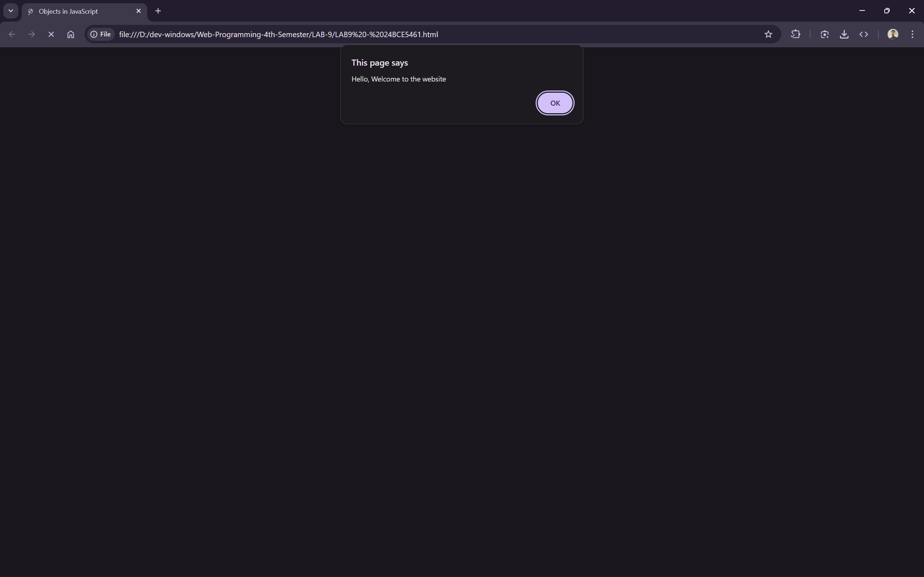

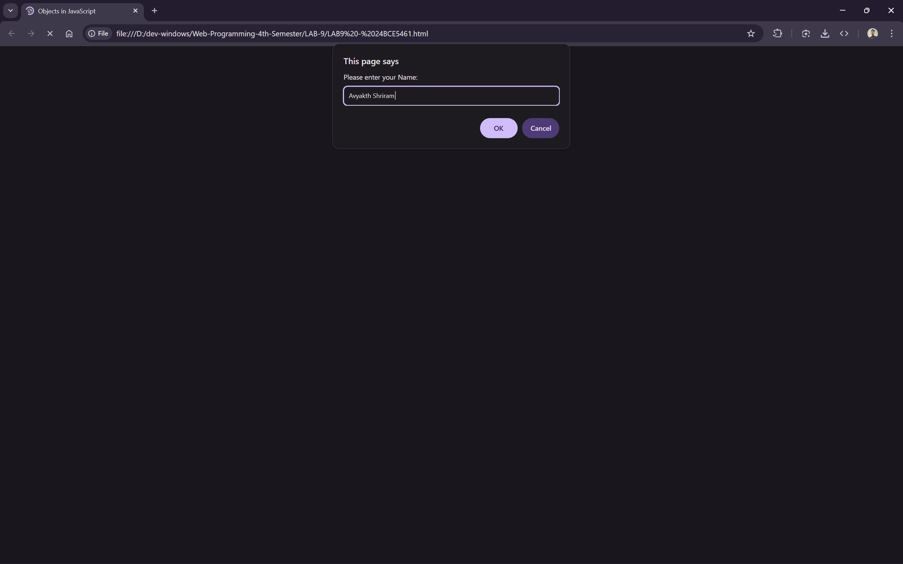

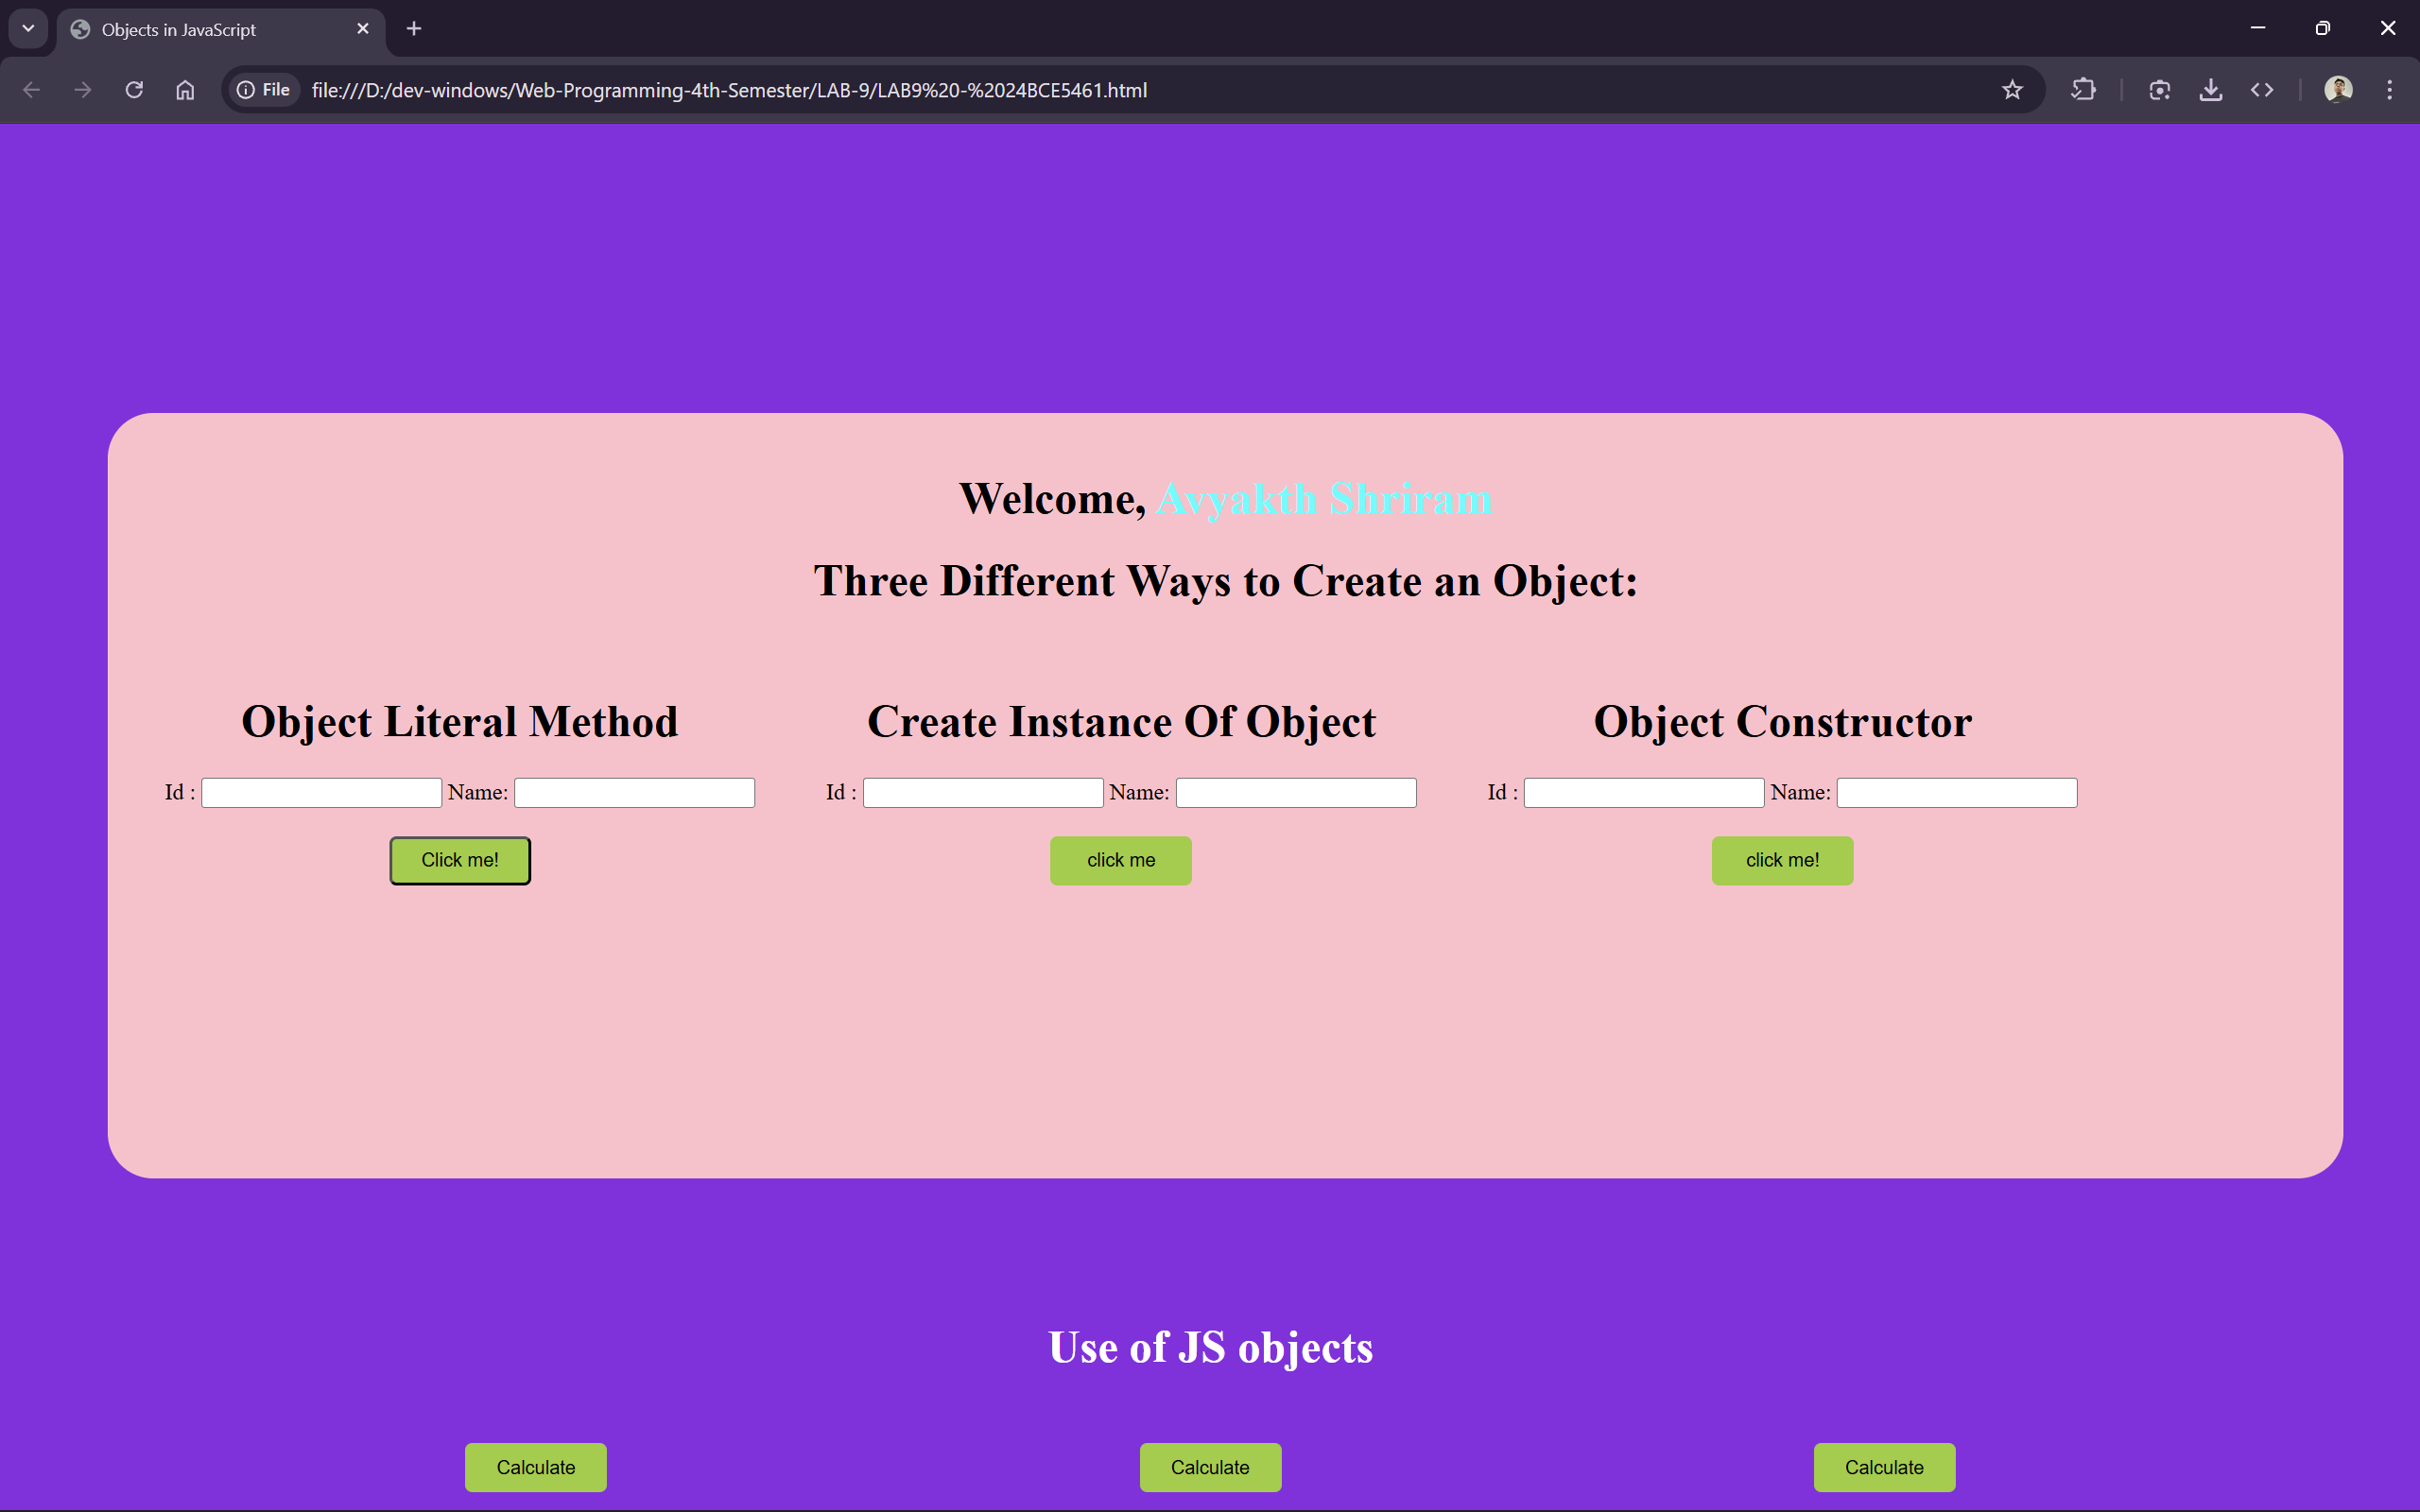

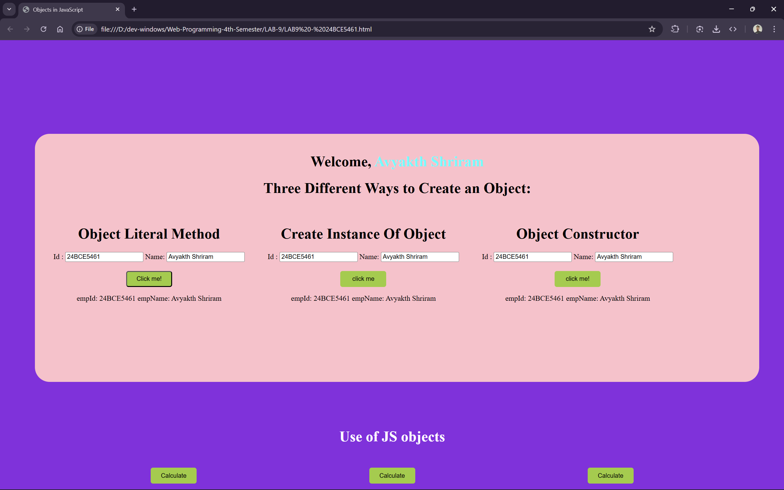

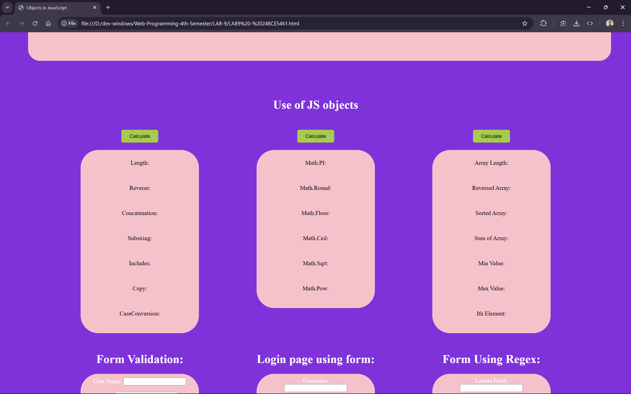

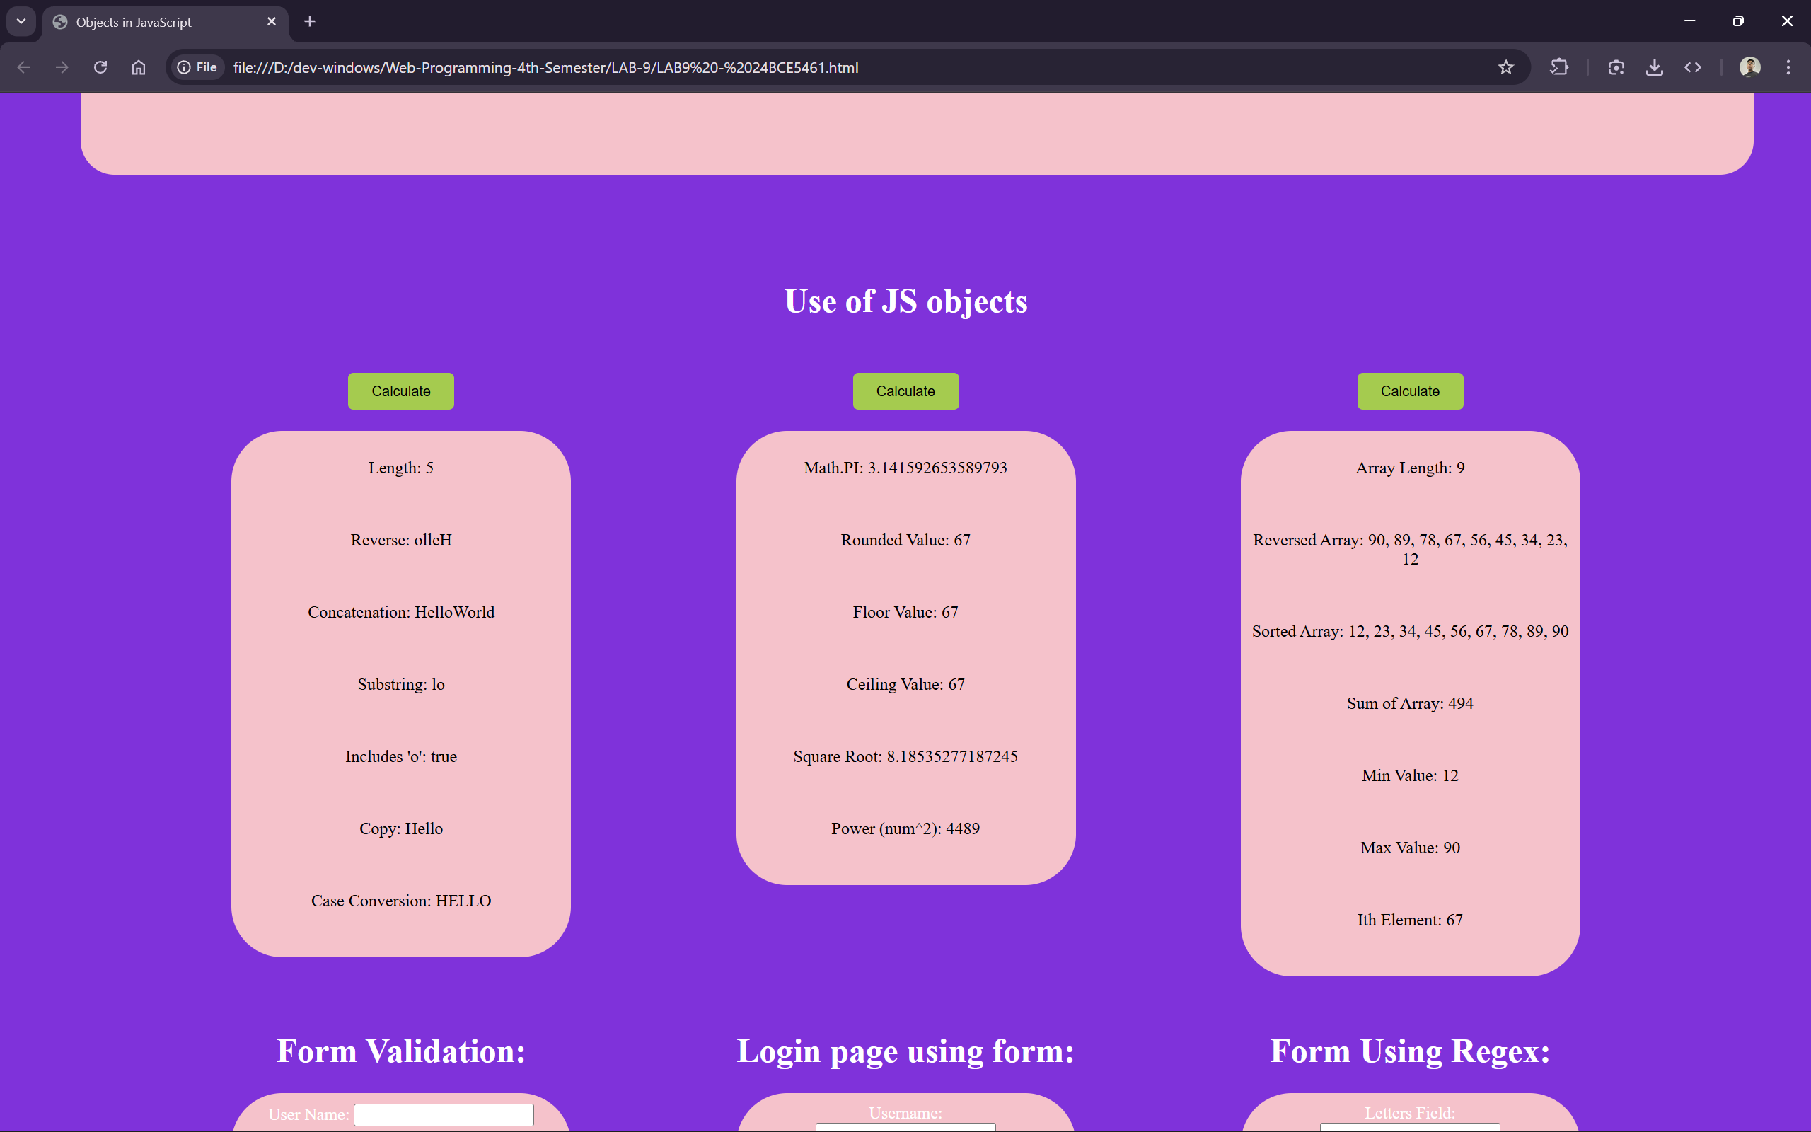

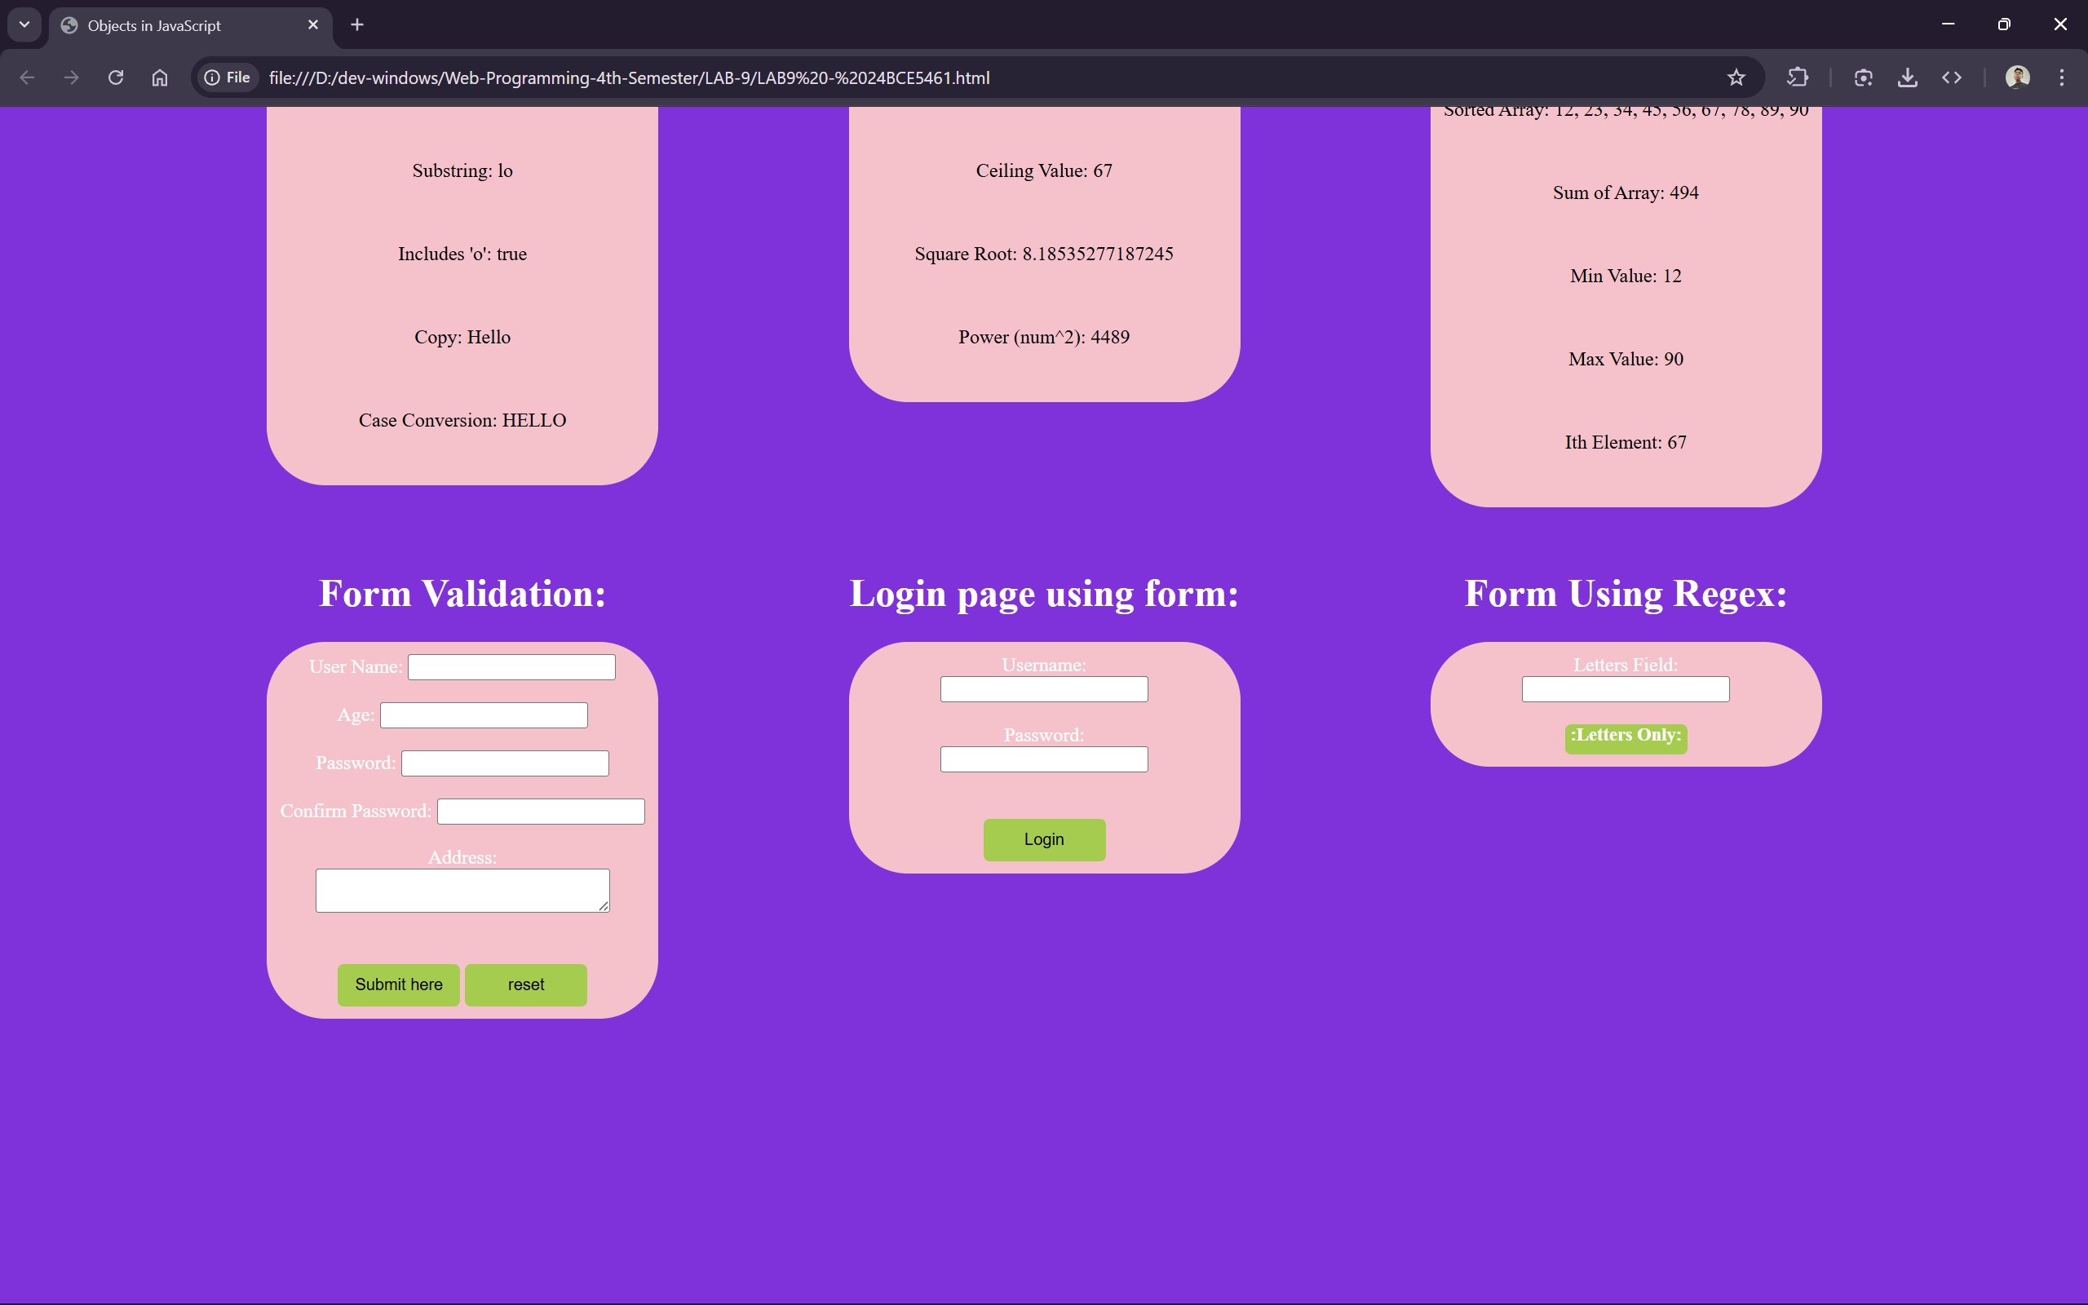

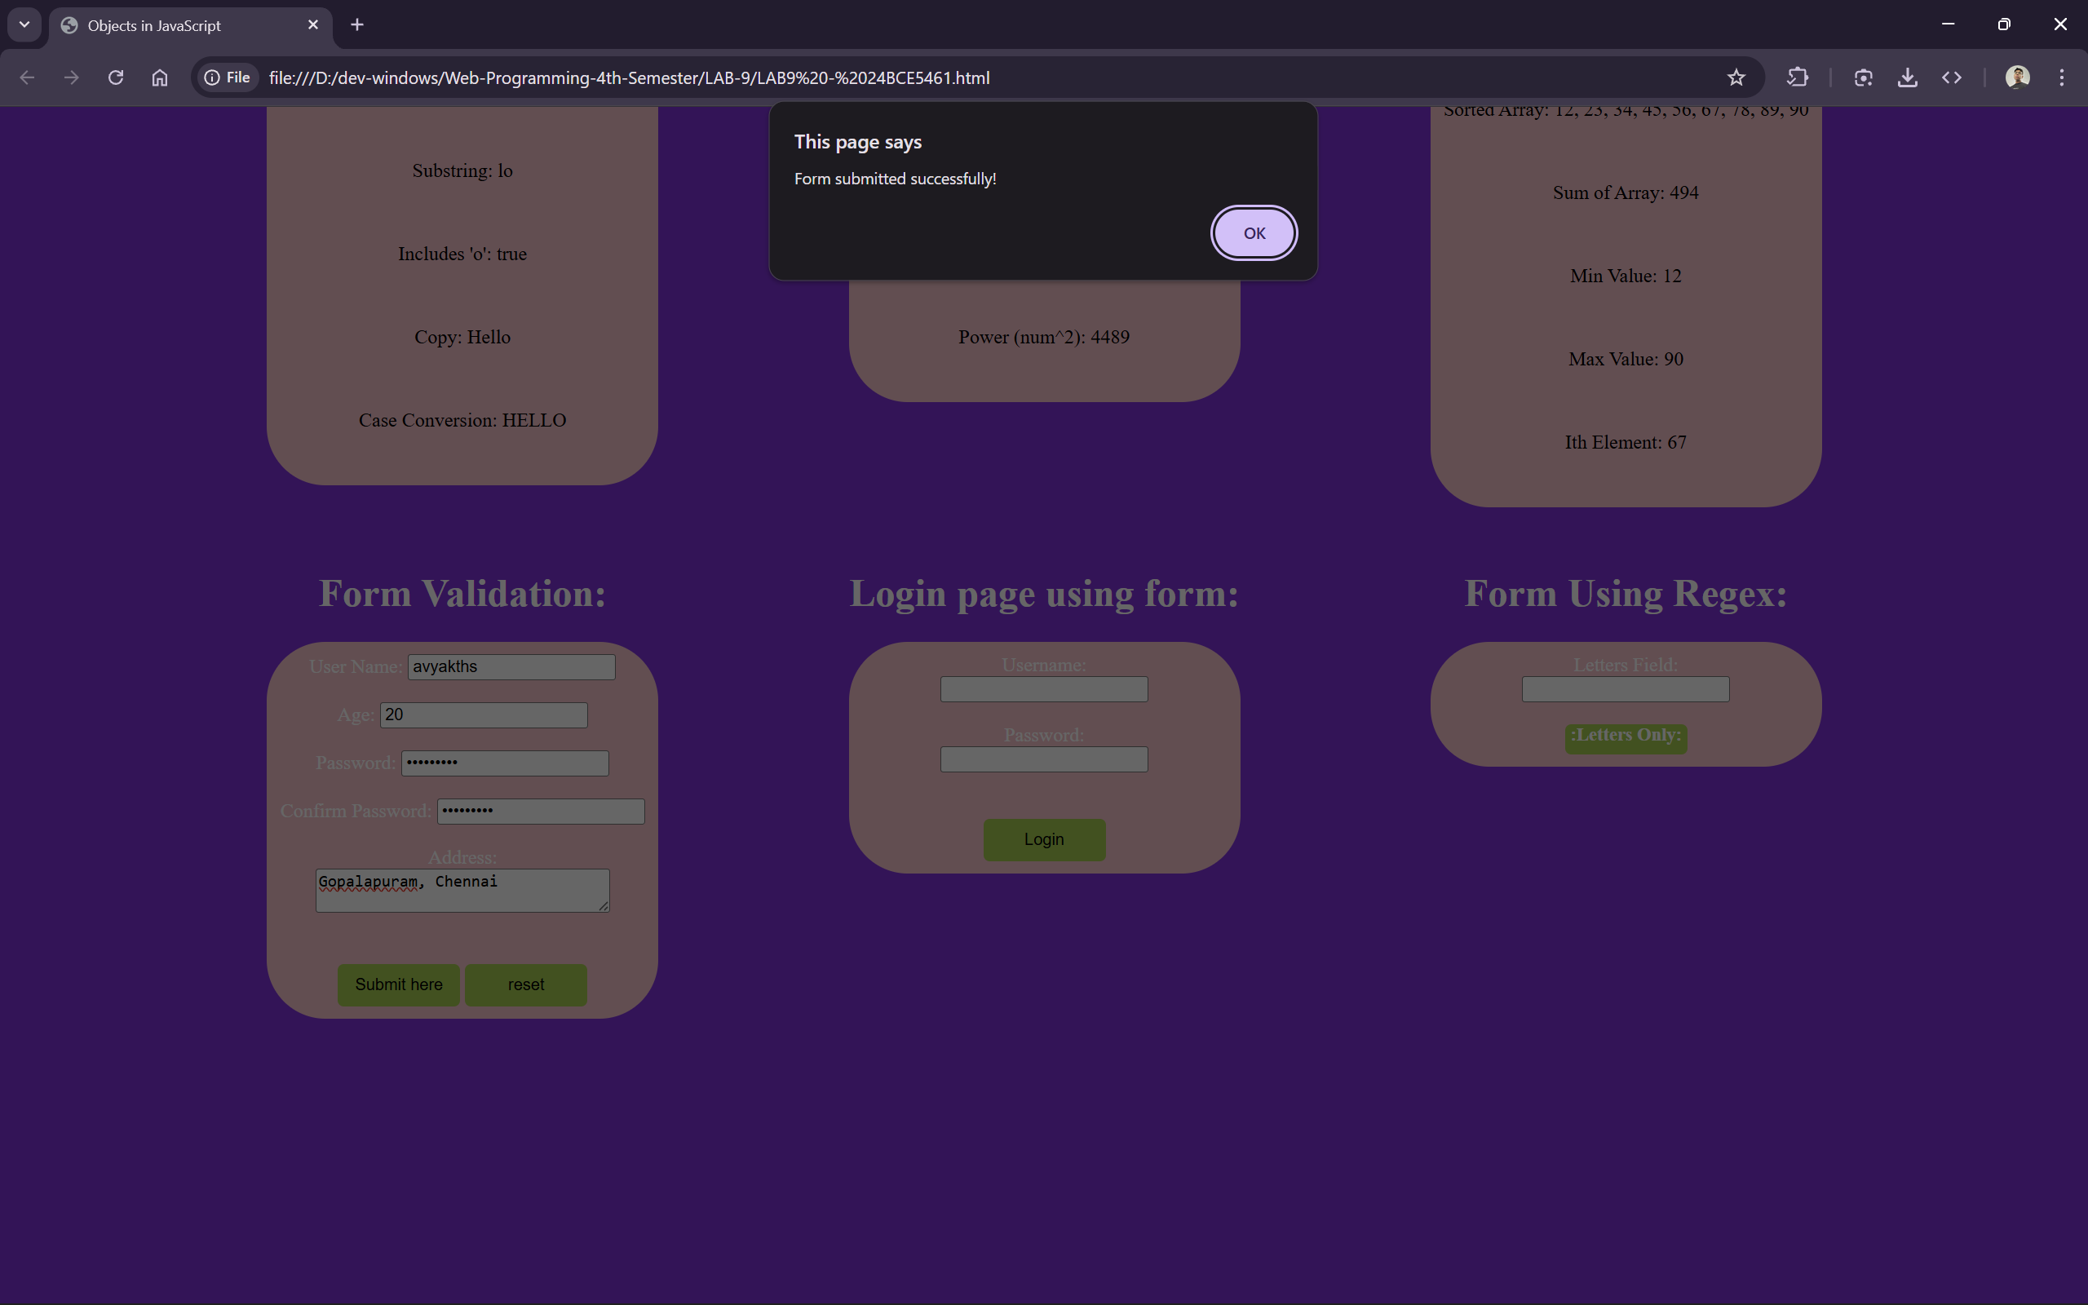

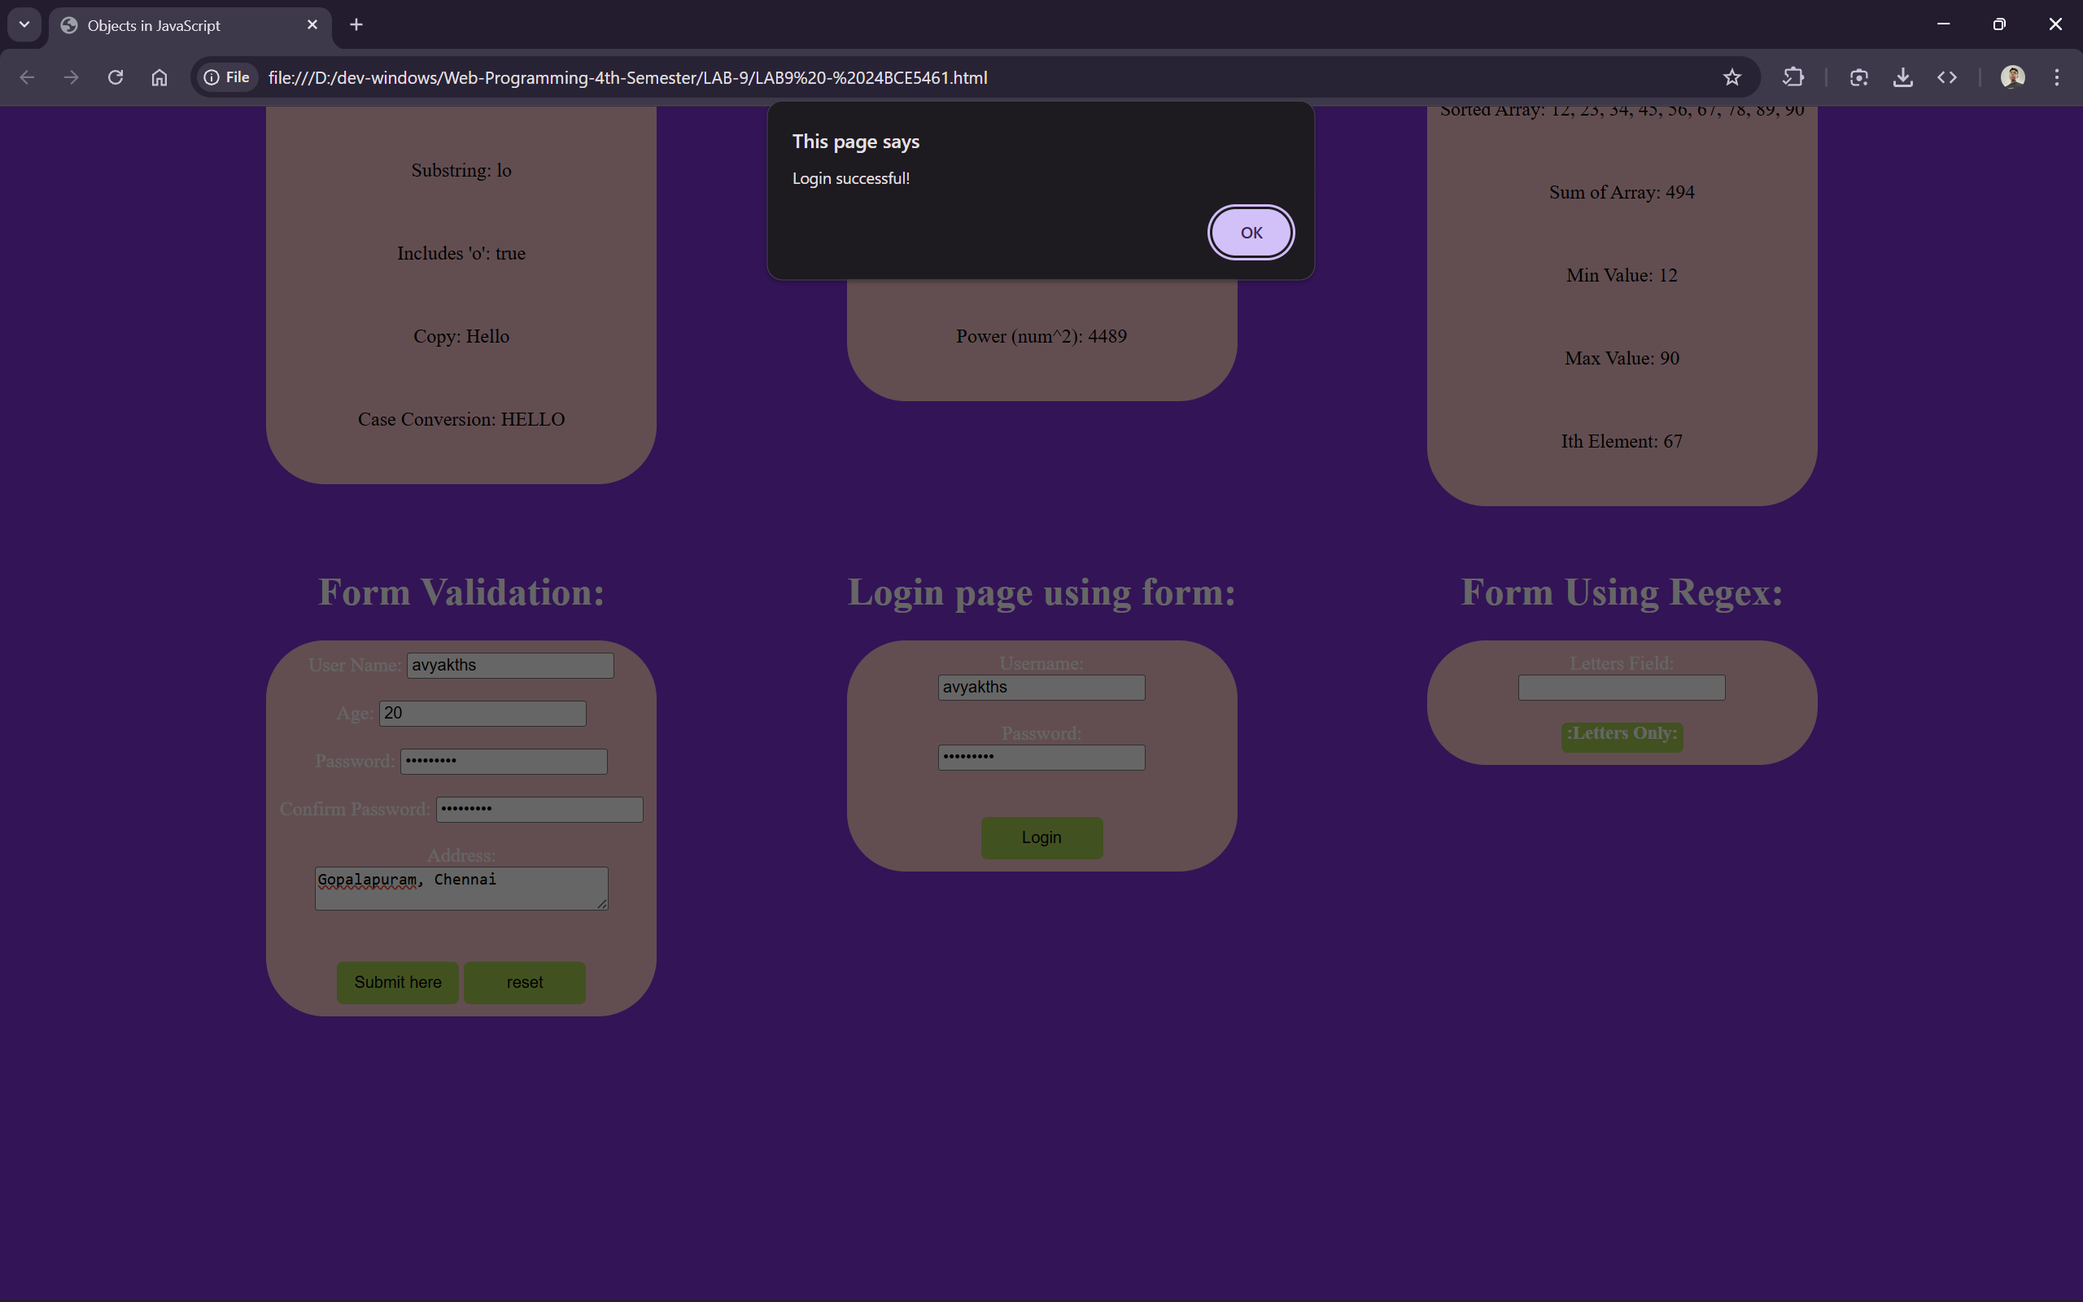

THANK YOU!!!

